*A*

*Report On*

**Industrial Training**

**At Laxmi Hydraulics Private Lim. Solapur**

Submitted in the partial fulfillment of the requirement for The Final Year B.Tech Semester-I in

### Electrical Engineering

To

**Laxmi Hydraulics Private Limited**

**By**

|  |  |  |
| --- | --- | --- |
| Sr.  No. | Name of Author | PRN Number |
| 1 | Mr. Shivaraj Basavraj Swami | 202101052018403 |

**Under the guidance of Prof. Anant Patil**

**DEPARTMENT OF ELECTRICAL ENGINEERING**

**N B Navale Sinhgad College of Engineering, Solapur (2024-2025)**

**N B NAVALE SINHGAD COLLEGE OF ENGINEERING, SOLAPUR DEPARTMENT OF ELECTRICAL ENGINEERING**

CERTIFICATE

This is to certify that the ***Industrial Training Report*** At LHP Motors and Pumps Company

Has been submitted by

|  |  |  |
| --- | --- | --- |
| Sr.  No. | Name of Students | PRN Number |
| 1 | Mr. Shivaraj Basavraj Swami | 202101052018403 |

For partial fulfillment of the requirement for Final Year B.Tech Semester I in Electrical Engineering as per curriculum laid by the P. A. H. Solapur University, Solapur during the academic year 2024-2025

### (Prof. Anant Patil) (Dr V. S. Biradar) GUIDE HOD, ELECT

(**Dr S. D. Nawale) PRINCIPAL**

* Acknowledgement

I wish to extend my heartfelt gratitude to LHP Motors for granting me the invaluable opportunity to participate in their esteemed training program. This experience has greatly contributed to my professional development and deepened my understanding of motor manufacturing.

I am especially thankful to **Mr. Dhairyasheel** for his outstanding guidance and support throughout the training period. His expertise, patience, and willingness to share knowledge have been crucial in refining my technical skills and broadening my industry insights.

My sincere thanks also go to the entire team at LHP Motors for their warm reception and ongoing assistance. The collaborative atmosphere and hands-on experience provided by LHP Motors have greatly enriched my learning journey and expanded my perspective on the complex processes involved in motor manufacturing.

This training has not only enhanced my technical knowledge but also motivated me to strive for excellence in the field of electrical engineering. The dedication and passion demonstrated by the professionals at LHP Motors have made a lasting impact on me.

Thank you once again, **LHP** Motors, and **Mr. Dhairyasheel**, for this exceptional opportunity. I eagerly anticipate applying the skills and knowledge acquired during this training to my future endeavors and contributing to the progress of the motor manufacturing industry.

* Abstract

This report gives a summary of the industrial training completed at LHP Motors, a top motor manufacturing company. The training covered various parts of motor manufacturing, such as production, design, and research and development (R&D). Key lessons included how different motor parts are made and the new designs created in the R&D department.

A major part of the training focused on how LHP Motors keeps their manufacturing costs low and their processes efficient. This was shown through the use of advanced automation technologies that make production smoother, reduce waste, and boost overall productivity. Learning about these modern techniques showed how important automation is for staying competitive and achieving excellence in manufacturing.

The training also involved practical sessions where participants used the machinery and tools on the production line. Seeing and interacting with skilled professionals at LHP Motors provided a complete view of the motor manufacturing process, from initial design to final assembly.

In conclusion, the industrial training at LHP Motors was a valuable experience that greatly improved our technical knowledge and understanding of efficient and innovative manufacturing practices.

**Table Of Contents**

## Introduction (07)

* 1. Background of the Training Program
  2. Purpose and Objectives
  3. Overview of LHP Motors

## Company Profile (10)

* 1. History of LHP Motors
  2. Mission and Vision
  3. Organizational Structure

## Training Overview (13)

* 1. Duration and Schedule

## Manufacturing Processes (16)

* 1. Overview of motor Manufacturing

1. **Automation in Manufacturing…** **(20)**
2. **Testing Of Motors (22)**
3. **LHP Motors Specs and Ranges (24)**
4. **Observations and Insights** **(28)**
5. **Conclusion…** **(30)**
6. **References…** **(31)**

**Table Of Figures**

fig 1.Roller Table Motor 9

fig 2.ultimo IE3 Motors 9

fig 3.Smoke Extraction Motor 9

fig 5. Plant 1 12

fig 4. plant 3 12

fig 6.plant 2 12

fig 7.Motor Winding 18

fig 8.Heat Treatment 19

fig 9. CNC Machine 20

fig 10. Automated Winding Machine 21

fig 11.Testing of Motors 23

fig 12.Product Range 24

fig 13.Ultimo IE4 Motor 25

fig 14.Crane And Hoist Duty Motors 26

fig 15.Railway Auxiliary Motor 27

**CHAPTER 1:**

# Introduction

LHP which stands for Laxmi Hydraulics Pvt. Ltd. is one of the largest manufacturers of electric motors, gear motors and gearboxes in India. Our range includes Safe Area LT Motors from 0.09 kW to 1000 kW and Hazardous Area LT Motors from 0.09 kW to 500 kW with voltage up to 690 V and in efficiency versions IE2, IE3, and IE4. They are the only company in India to offer such a vast range of motors.

LHP motors are well-known for their quality, energy-efficiency, reliability and quick deliveries. Every motor is built using high quality material, undergoes vacuum pressure impregnation after winding and is fully tested on a SCADA controlled, regenerative test set-up, which is unique in India.

Their two world-class manufacturing plants in Solapur, India, are spread over 55,000 sq.

m. with a covered area of 20,500 sq. m. These state-of-art-facilities, with most of the critical processes right from designing to the final testing being in-house, are capable of producing 200,000 motors and 25,000 gearboxes every year.

They have won the trust of over 6,500 regular customers from various sectors, such as power, process, oil &amp; gas, steel, cement, HVAC, automotive, chemical, pharmaceuticals, textile, food & beverages, material handling, railways, marine, infrastructure, construction machinery and so on. They regularly cater to the large requirements from these sectors in the shortest possible time with our state-of-the-art infrastructure. We also provide special motors, such as textile, marine/naval duty, railway auxiliary, and multi-speed motors and also undertake the development of customised solutions.

## Background of training program:

LHP Motors, based in Solapur, specializes in manufacturing high-performance electric motors. Established with a commitment to innovation and quality, LHP Motors offers a comprehensive training program. This program focuses on developing expertise in motor design, manufacturing processes, and advanced automation techniques, ensuring engineers are equipped to drive future advancements in electric mobility and industrial automation.

## Purpose and Objectives:

* + - Achieve and maintain a leadership position through high growth business with reasonable profit margins
    - Cater to the changing needs and expectations of interested parties
    - Set measurable, time-bound, result-oriented objectives and targets, integrate them with the performance evaluation system of employees and monitor them
    - Religiously adopt 5S, Kaizen, TPM, Kanban, QMS, SPC and similar world- class practices in all spheres of activities

## OverView of LHP Motors:

Laxmi Hydraulics Private Limited (LHP) Motors specializes in the manufacturing of electric motors and pumps. Based in Solapur, India, LHP is renowned for its commitment to innovation, quality, and reliability in the industrial motor sector. The company excels

in producing a wide range of motors tailored for various applications, including industrial automation, automotive, and agricultural sectors. LHP Motors emphasizes advanced technology, precision engineering, and sustainable practices to meet global standards and customer requirements effectively.

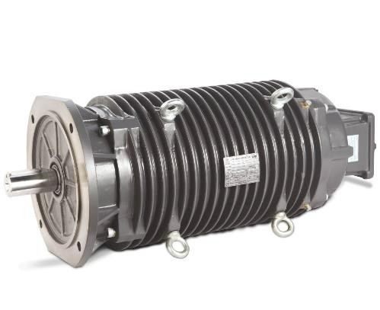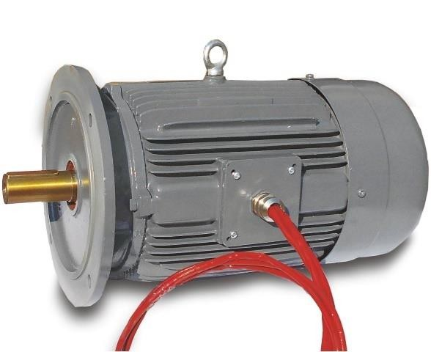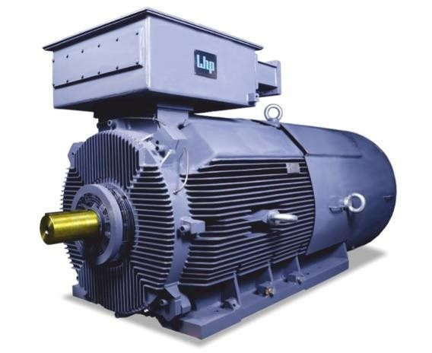

*fig 1.Roller Table Motor*

*fig 3.Smoke Extraction Motor*

*fig 2.ultimo IE3 Motors*

**CHAPTER 2:**

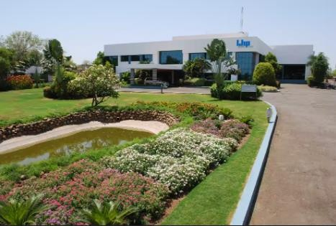

# Company Profile

## History Of LHP Company

LHP laid its foundation in 1981 as a motor and pump manufacturer at Solapur in India.

During the 80s the first decade of its operations, the company invested its time and resources to be future-ready by researching the needs of various industry verticals, developing and establishing proper manufacturing methods, inducting and training a team of like-minded engineers and technicians, and by developing a committed vendor base.

Once equipped, in the 90s the company expanded its product range, taking the tally to more than 2500, LHP focused on reaching out and winning confidence of several companies in India from various industry segments. The ever-growing client list included major corporates, PSUs and OEMs.

After gaining a firm footing in the market, the first decade of the 21st century was the time to consolidate position and be ready for a quantum leap. The company established a new world class, environmentally-friendly plant possessing the capacity of manufacturing nearly motors per annum.



The plant employs state-of-the-art manufacturing technology and system ensuring economical production. Our competency in providing solutions to specific customer requirement has helped us to develop the product basket of more than 6000 product variants including advanced technology energy-efficient motors, flame-proof motors and gear motors.

Today, we take pride in associating with more than 4000 prestigious clients. Our International Business Division is growing rapidly with recognition from the Europe, Middle Eastand Africa.

## Mission And Vision :

* + - Create the required competencies in all employees
    - Committed to provide everyone are educated & trained to apply our policy on Environment, Health & Safety in their daily work
    - Contribute to the development of communities that we operate in or have influence on our business
    - Enhance coordination and transparency through the effective use of information technology

## Organizational Structure:

*fig 5. Plant 1*

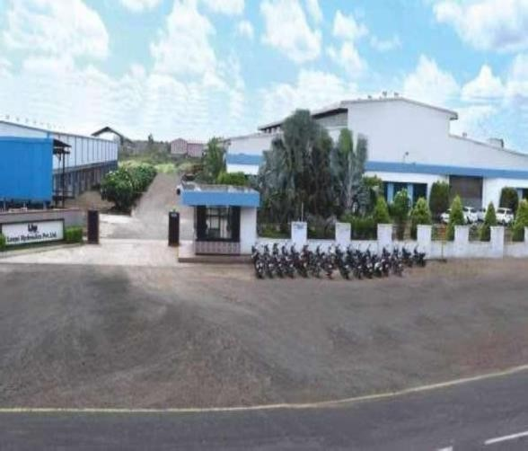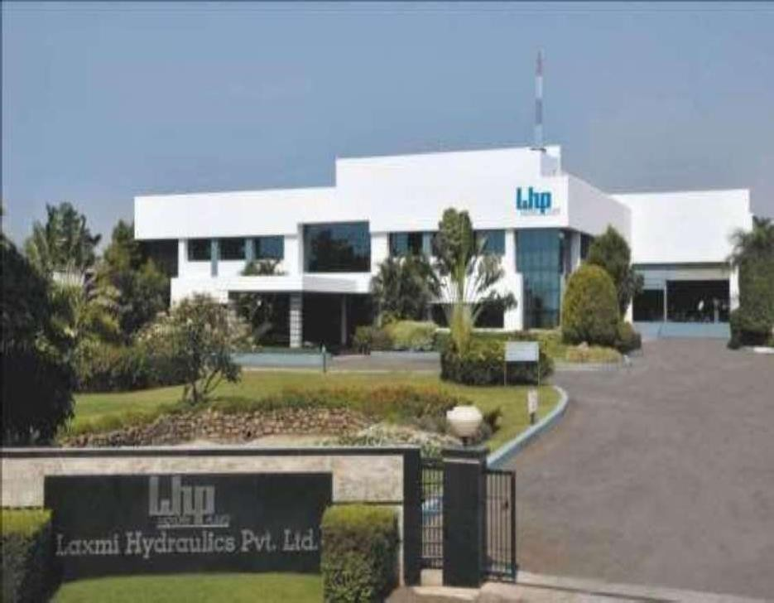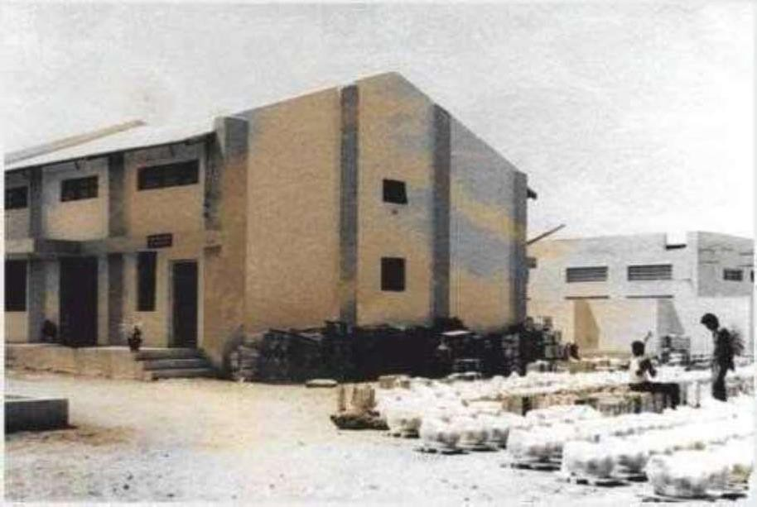

*fig 6.plant 2*

*fig 4. plant 3*

**CHAPTER 3:**

# Training Overview

The training program at LHP is designed to equip participants with comprehensive knowledge and hands-on experience in motor and pump manufacturing. The program covers various aspects, including design principles, manufacturing processes, quality control, and advanced automation techniques. Trainees gain exposure to the latest technologies and industry best practices, ensuring they are well-prepared to contribute to future advancements**.**

## Schedule and Time:

**Day 1-2:** Introduction to LHP, safety protocols, and company policies.

**Day 3-4:** Fundamentals of electric motor and pump design. **Day 5-7:** Hands-on sessions in manufacturing and assembly. **Day 8-10:** Quality assurance and testing procedures.

**Day 11-12:** Advanced automation techniques and applications.

**Day 13-14:** Real-world case studies and troubleshooting.

**Day 15:** Assessment and feedback session.

## Timing:

We were told to come at 3:00 pm everyday till the 6:00 pm , Wednesday was considered as the holiday as the industries keep closed

# Products Available In the Industry

* Oil and Gas Industries Power Plants Railways Marine/Naval
* Steel Industries Pharmaceuticals Industries Cements
* Sugar
* Textile Industries HVAC
* Chemical and Paints Fertilisers
* Food and Beverages Automotive/General Engineering Electric Vehicles
* Machine Tools Material Handling Multi-Level Parking
* Construction Machinery Paper Industry
* OEM
* Water Supply and WTP/STP

# Products and Ranges

**Electric Motors**

1. IE4 Motors Ultimo
2. IE3 Motors Supremo
3. IE2 Standard Motors
4. Flame-proof Motors
5. Increased Safety motors
6. Smoke Extraction Motors
7. Motors for Fire Fighting Pump
8. Crane & Hoist Duty Motors
9. Brake Motors
10. Inverter Duty Motors
11. Roller Table Motors
12. Encoder Motors
13. Textile Motors
14. Naval & Marine Duty Motors
15. Railway Auxiliary Motors
16. Multi-speed Motors
17. Cooling Tower Motors
18. Single Phase Motors

**Gear Motors**

1. Gear Motors
2. Planetary Gear Motors
3. Flame-proof Brake Gear Motors
4. Brake Gear Motors
5. Helical Bevel Gear Motors
6. Roller Table Gear Motors
7. Heavy Duty Parallel Shaft Gear
8. Motors
9. Parallel Shaft Gear Motors
10. Single Stage Reducer
11. Motor Mount Reduce

**CHAPTER 4:**

# Manufacturing Processes

At Laxmi Hydraulics Private Limited (LHP), the manufacturing processes for motors and pumps involve both hands-on craftsmanship and advanced automated machinery to ensure precision and quality.

Hands-on Manufacturing Processes:

### Initial Assembly:

* + - Skilled technicians assemble core components, such as stators and rotors, manually. This stage requires meticulous attention to detail to ensure proper alignment and fitting.

### Winding:

* + - Manual winding of coils is performed for specific motor types, ensuring precision in the number of turns and consistency in winding patterns.

### Inspection and Quality Control:

* + - Technicians manually inspect components and assemblies to detect any defects or inconsistencies. This process includes visual inspections and using tools like micrometers and calipers.

### Custom Fabrication:

* + - For custom or specialized motors and pumps, parts are often fabricated by hand to meet specific design requirements.

Automated Manufacturing Processes:

### CNC Machining:

* + Computer Numerical Control (CNC) machines are used to manufacture precision components such as housings, shafts, and end bells. This automation ensures high accuracy and repeatability.

### Automated Winding Machines:

* + For high-volume production, automated winding machines are used to wrap coils efficiently and consistently, reducing manual labor and enhancing productivity.

### Robotic Assembly:

* + Robotic arms are employed in the assembly line to handle repetitive tasks such as inserting components, fastening screws, and applying adhesives. This improves speed and reduces the risk of human error.

1. Automated Testing:
   * Automated testing rigs are used to perform electrical and performance tests on finished products. These machines provide precise measurements and ensure each unit meets stringent quality standards.
2. Packaging:
   * Automated packaging machines ensure that motors and pumps are securely packed for shipping, minimizing the risk of damage during transit.

By integrating both hands-on and automated processes, LHP ensures a balanced approach to manufacturing, leveraging human expertise and advanced technology to deliver high-quality products.

# 4.1 Overview of motor manufacturing and info of each department

Laxmi Hydraulics Private Limited (LHP) manufactures high-performance electric motors using a blend of hands-on craftsmanship and advanced automated machinery. The process involves precise assembly, coil winding, CNC machining, robotic assembly, and rigorous quality testing, ensuring reliable and efficient motors for various industrial applications.

### Manufacturing

Our dust-free manufacturing plants are equipped with automatic coil winding machines, advanced CNC machines, Vacuum Pressure Impregnation (VPI) plants, regenerative test setup, conveyor zed assembly lines and paint shops. These dust-free plants are certified with ISO 9001:2015 and practice 5S, KANBAN and TPM.

### Motor Winding

*fig 7.Motor Winding*

We have a complete automatic winding set-up that can handle up to 500 windings per day. For large size motors, winding is carried out manually by our trained and experienced technicians. After winding, each and every motor undergoes Vacuum Pressure Impregnation (VPI), which imparts additional strength and reliability to the motor.

### Machine Shop

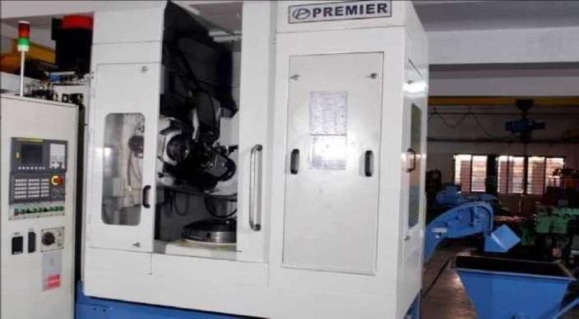

All the machining operations are carried out in-house. We have a large machine shop equipped with advanced CNC machines to ensure precision. It allows us complete control on time and quality.

### Heat Treatment

We have complete heat treatment plant where the processes such as annealing, tempering, normalizing, stress relieving, toughening and case carburizing are carried- out. Quenching media like oil quenching, furnace cooling and accelerated air cooling are possible. Process control parameters are controlled via. software to ensure high level of reliability and repeatability.

The facility is extensively used for heat treatment of all the gears to ensure reliable performance of gearboxes, shafts used for critical operations are hardened and tempered to extend the product life and fabricated gearbox components are stress relieved suitably for ease of machining.

Hardness Tester is used to ensure that the hardness range is within acceptable limits and for desired assurance about micro structure, microscope is used by our QC team.

*fig 8.Heat Treatment*

**CHAPTER 5:**

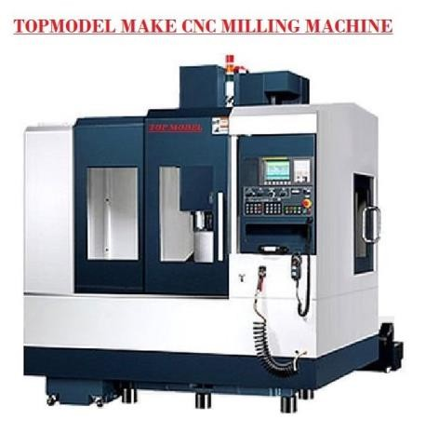

# Automation in Manufacturing

Automation in manufacturing has revolutionized the industry, bringing significant improvements in efficiency, precision, and productivity. At Laxmi Hydraulics Private Limited (LHP), automation plays a crucial role in the production of high-performance electric motors and pumps. The integration of advanced technologies such as Computer Numerical Control (CNC) machines, robotic arms, and automated testing rigs has transformed traditional manufacturing processes.

Key Aspects of Automation at LHP:

### CNC Machining:

* + - CNC machines ensure the precise fabrication of components like housings, shafts, and end bells. These machines follow computer-aided design (CAD) models to achieve high accuracy and consistency, reducing human error and material wastage.

*fig 9. CNC Machine*

### Robotic Assembly:

* + - Robotic arms handle repetitive and intricate tasks such as component insertion, screw fastening, and adhesive application. This speeds up the assembly process and maintains uniform quality across all units.

### Automated Winding Machines:

o These machines efficiently wind coils for motors, ensuring consistent tension and pattern. This automation increases production speed and reduces manual labor, allowing for high-volume manufacturing.

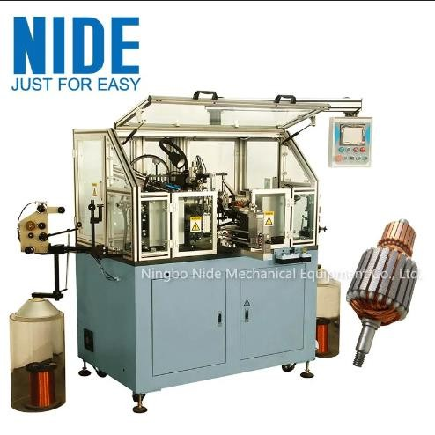

### Automated Testing:

* + - Automated testing rigs perform comprehensive electrical and performance tests on finished products. These systems provide precise measurements and ensure each motor and pump meets stringent quality standards before leaving the factory.

### Packaging Automation:

* + - Automated packaging machines ensure secure and efficient packing of products, minimizing the risk of damage during transit and improving overall logistics.

By leveraging automation, LHP enhances production capabilities, maintains high- quality standards, and remains competitive in the global market. This integration of technology and innovation ensures the delivery of reliable and efficient products to customers.

*fig 10. Automated Winding Machine*

**CHAPTER 6:**

# Testing of Motors

## Various Testers used for performing tests on Machine

1. Pin hold Tester
2. Breakdown Voltage Tester
3. Twisted Pair Making Machine
4. Spring Back Tester
5. Abbreviation Tester
6. CUT through Tester
7. Peel Tester
8. Mandrel Winding Tester
9. Elongation Tester
10. CM~~M~~ Coordination Measuring Machine Gear and Motion Tester

Testing of motors at Laxmi Hydraulics Private Limited (LHP) ensures each unit meets high-quality standards and performs reliably in various applications. The testing process includes:

1. Electrical Testing:

o This involves checking the motor’s insulation resistance, winding resistance, and high-potential (hipot) testing to ensure electrical integrity and safety.

1. Performance Testing:
   * Motors are tested for parameters such as efficiency, power output, torque, and speed under different load conditions. This ensures they meet design specifications and perform optimally in real-world applications.

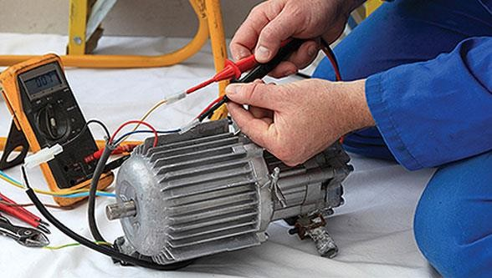

1. Thermal Testing:

o Motors undergo thermal analysis to evaluate their ability to dissipate heat and maintain stable operating temperatures, preventing overheating and ensuring longevity.

1. Vibration and Noise Testing:
   * Vibration and noise levels are measured to ensure they are within acceptable limits, guaranteeing smooth and quiet operation.
2. Endurance Testing:
   * Long-term performance and durability are assessed by running motors continuously under load to simulate real-life usage and identify potential failures.

These rigorous testing procedures ensure LHP motors are reliable, efficient, and built to last.

*fig 11.Testing of Motors*

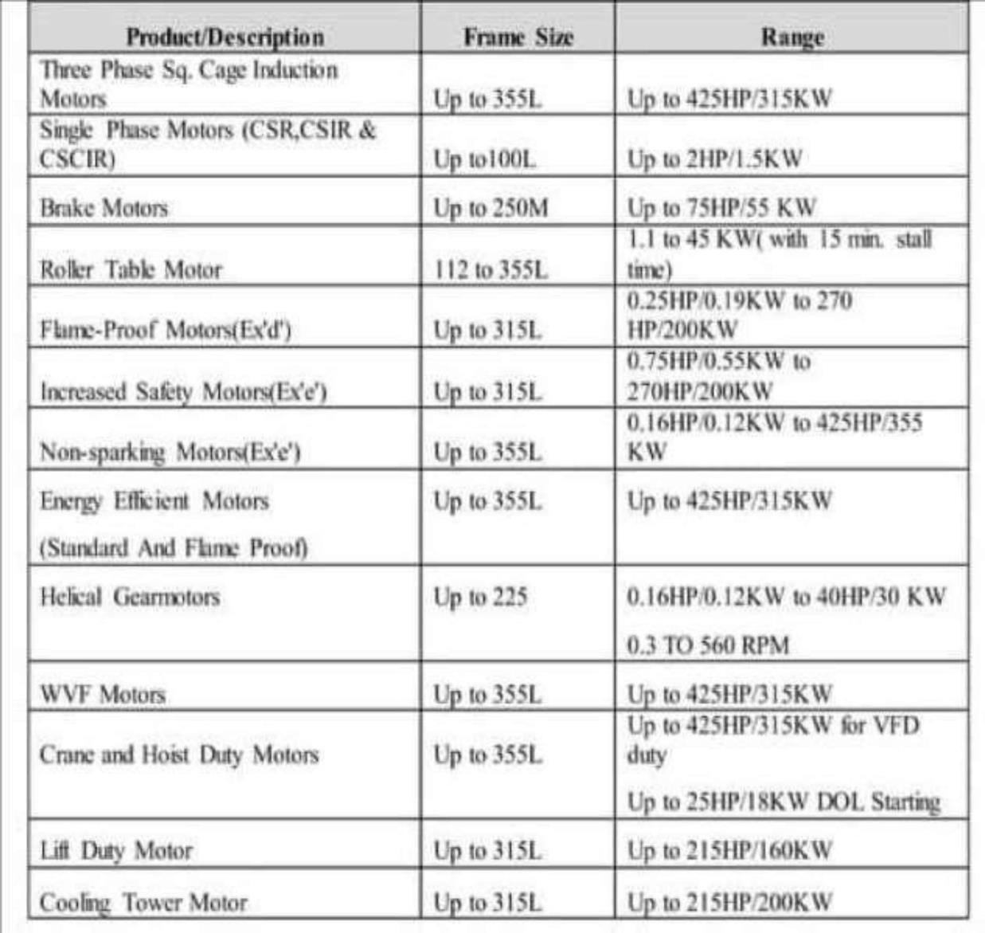

**CHAPTER 7:**

**7.LHP Motors Specs And Ranges**

*fig 12.Product Range*

## Ultimo - IE4 Motors

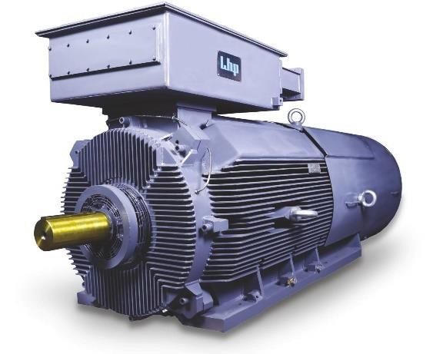

*fig 13.Ultimo IE4 Motor*

IE4 motors, also known as **Super Premium Efficiency Motors**, are built around standard 3-phase motors using special materials. They are suitable for a range of applications. IE4 motors from LHP are developed in accordance with energy-saving guidelines from IEC (IEC/ EN 60034-30-1:2014) and approved by BIS as per the latest IS 12615

|  |  |
| --- | --- |
| Range | 0.09 kW to 1000 kW |
| Synchronous RPM | 3000, 1500, 1000, 750 |
| Mounting | Foot (B3), Flange (B5), Face (B14), Foot cum Flange (B35) and combinations |
| Frame | 63 to 450 |
| Protection | IP55 as standard  IP56, IP57, IP66, IP67 as optional |
| Insulation | F Class |

|  |  |
| --- | --- |
| Voltage | Standard: 415 V  Optional: 110 V to 690 V |
| Frequency | 50/60 Hz |
| Duty | S1 |

## Cranes and Hoist Duty Motors

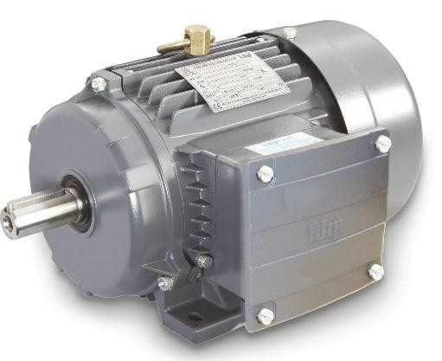

Crane and hoist duty motors are most suitable for demanding applications where intermittent duty drives are required. These are duty-type rated motors, which require a high starting torque with a low starting current. Crane and hoist duty motors have to withstand frequent start-stops and reversal operations.

*fig 14.Crane And Hoist Duty Motors*

Range 0.37 kW to 315 kW

Synchronous RPM 1500, 1000, 750 Mounting Foot (B3), Flange Frame 71 to 355

Protection IP55 as standard IP56, IP57, IP66, IP67 as

optional

Insulation F Class

Voltage Standard: 415 V

Optional: 110 V to 690 V Frequency 50/60 Hz

Duty S1,S2,S3

S5, S7, S8

## Railway Auxiliary Motor

*fig 15.Railway Auxiliary Motor*

Voltage

Standard: 415 V

Optional: 110 V to 690 V

Range

0

Up to 500 kW

Frequency

50/60 Hz

Synchronous RPM

3000, 1500, 1000, 75

Duty S1

Mounting

Foot (B-3), Flange (B-5)

Face (B-14), Pad (B-30) and combinations

Frame Up to 355

Protection

IP55 as standard

IP56, IP57, IP66, IP67 as optional

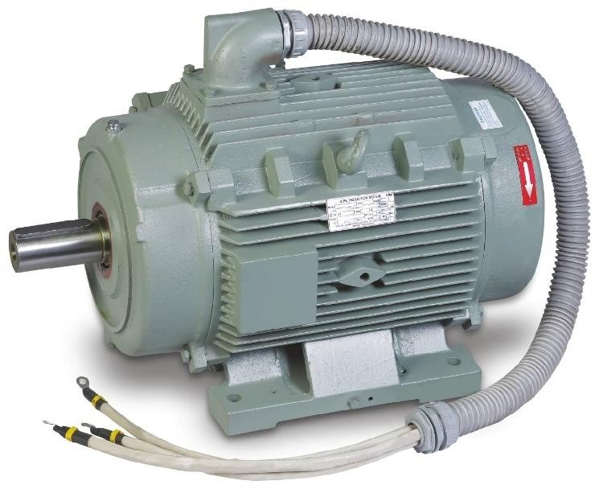

Insulation F Class

**CHAPTER 8:**

# 8.Observations and Insights

At Laxmi Hydraulics Private Limited (LHP), observations and insights derived from the manufacturing and testing processes are pivotal in maintaining high standards of quality and efficiency. Key observations and insights include:

1. Quality Control:
   * Consistent monitoring and inspection reveal that adherence to stringent quality control measures significantly reduces defects and rework. This has led to the implementation of standardized procedures and checklists to ensure every motor meets precise specifications.
2. Automation Benefits:
   * Insights from automated processes indicate substantial improvements in production speed and precision. CNC machining and robotic assembly have minimized human error, reduced material wastage, and ensured consistent product quality, highlighting the importance of further investment in automation technology.
3. Employee Expertise:
   * Observations show that skilled technicians play a critical role in the initial assembly and inspection stages. Continuous training and skill development programs have proven essential in maintaining high craftsmanship standards, especially in custom and specialized motor production.
4. Testing Efficiency:
   * Data from various testing phases underline the importance of comprehensive testing protocols. Electrical, performance, thermal, and endurance testing have identified potential issues early, leading to design adjustments and improved product reliability.
5. Customer Feedback:
   * Insights gained from customer feedback have driven product enhancements and innovation. Understanding customer needs and applications has led to the development of tailored solutions and improvements in existing product lines.

These observations and insights at LHP emphasize the value of a balanced approach combining advanced technology, skilled craftsmanship, and continuous feedback loops. This ensures the production of high-quality, reliable motors and pumps that meet and exceed customer expectations.

**CHAPTER 9:**

# 9.Conclusion

Laxmi Hydraulics Private Limited (LHP) exemplifies excellence in motor and pump manufacturing through a blend of hands-on craftsmanship and advanced automation. The company's commitment to quality, innovation, and customer satisfaction is evident in every aspect of their operations, from meticulous assembly processes to rigorous testing protocols. The comprehensive training program equips employees with essential skills, fostering a culture of continuous improvement and technological advancement. Observations and insights highlight the critical role of automation, skilled labor, and thorough testing in ensuring product reliability and efficiency. By integrating these elements, LHP not only maintains high standards but also drives forward industry innovations, meeting diverse customer needs with precision and expertise**.**

Laxmi Hydraulics Private Limited (LHP) excels in motor and pump manufacturing by integrating hands-on expertise with advanced automation. Their comprehensive training, stringent quality control, and rigorous testing ensure reliable, high- performance products. LHP's commitment to innovation and customer satisfaction drives their success in meeting diverse industrial needs.

**CHAPTER 10:**



**10.References**

LHP Website:

<https://lhpmotor.com/>

https://lhpmotor.com/careers/

https://lhpmotor.com/management/

https://lhpmotor.com/resources/ https://lhpmotor.com/special-motors/